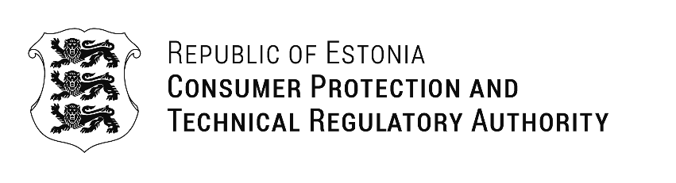
Zaiga Liepina  Consumer Rights Protection Center of Latvia | Our Ref: 12.05.2026 No 1-9/2026/0571
Letter of Support
The Estonian Consumer Protection and Technical Regulatory Authority (TTJA) is pleased to support the Latvian Consumer Rights Protection Centre in the EU Single Market Programme project “SMP-CONS-2026-ADR-RAD”. The project aims to strengthen the operational capacity and expertise of the Latvian Consumer Disputes Committee and improve access to ADR mechanisms.

TTJA supports the objectives of the project and is prepared to contribute to the exchange of knowledge and best practices. TTJA is willing to participate at expert level in workshops and a high-level international ADR seminar planned during the Latvian Presidency of the Council of the European Union in 2028.

We value regional cooperation and believe that these activities will strengthen collaboration and contribute to the effective development of consumer protection and alternative dispute resolution practices.

We look forward to constructive cooperation throughout the implementation of the project.

Yours sincerely,
Kristi Talving
Director General

Kristina Vaksmaa-Tammaru
+372 6201708 Kristina.Vaksmaa-Tammaru@ttja.ee

